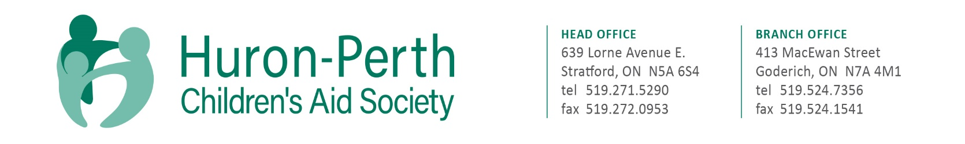
The Society is currently accepting resumes for the full-time position as follows:

CHILD PROTECTION WORKER - INTAKE

Located in the picturesque town of Goderich, and Stratford, Ontario, we are committed to partnering with communities to provide professional child protection services. We advocate for and protect children’s rights; support and strengthen families and we are leaders for positive change in our community.
Huron-Perth CAS is dedicated to building a workforce that reflects the diversity of the community in which we live and serve. We encourage applicants from African Canadian, Indigenous, people with disabilities, 2SLGBTQ+ communities to apply and to self-identify in their cover letter. We are also committed to providing barrier-free and accessible employment practices for all. Accommodations are available on request for candidates taking part in all aspects of the selection process.

Summary of Duties and Responsibilities:
This position will provide protective and preventive services to families and children. The successful applicant will assume responsibility for child welfare caseloads including responsibility for assessing family and individual functioning, and the provision of child protection and therapeutic intervention services.

Qualifications:
Bachelor of Social Work (BSW) degree from a recognized university is preferred however, consideration will be given to a BA in a related field with related experience or a CYW diploma with 5 years’ experience. Authorized Child Protection Worker designation preferred.

Candidates who meet the qualifications are welcome to apply and should do so in writing to Kendra Baker, Human Resources Coordinator at HR@h-pcas.ca no later than March 28, 2023. A cover letter and full resume, including three current professional references would be appreciated.

We thank all applicants, however, only those to be interviewed will be contacted.

