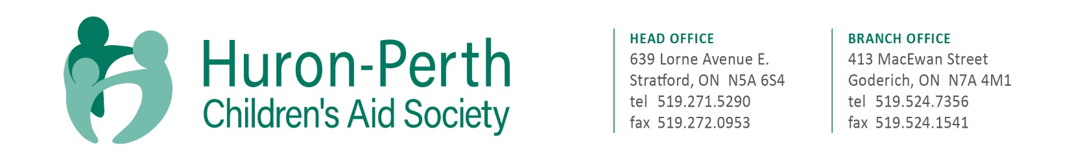
The Society is currently accepting resumes for the full-time position as follows:

EMERGENCY AFTER HOURS WORKER
Located in the picturesque town of Goderich, and Stratford, Ontario, we are committed to partnering with communities to provide professional child protection services. We advocate for and protect children’s rights; support and strengthen families and we are leaders for positive change in our community.
Huron-Perth CAS is dedicated to building a workforce that reflects the diversity of the community in which we live and serve. We encourage applicants from any background, including African Canadian, Indigenous, people with disabilities, and 2SLGBTQ+ communities to apply and to self-identify in their cover letter. We are also committed to providing barrier-free and accessible employment practices for all. Accommodations are available on request for candidates taking part in all aspects of the selection process.

Summary of Duties and Responsibilities:
Staff occupying these positions will be authorized to represent the agency in child protection matters as they relate to emergency services and associated investigations and assessment.
To present the agency with a screening and clinical assessment capacity by examining all requests for information, service, and subsequently referring to resources located either internal or external to the agency.
The nature of service provided will be to respond to all contacts as presented and to diffuse crisis as presented outside of regular agency hours and to stabilize events presented until cases can be assumed by regular day staff.
This position is designed to ensure requirements are met in accordance with the mandate directive as an authorized child welfare agency.
Staff occupying these positions will be prepared to work independently with appropriate consultation with managers assigned to on-call.

Duties and Responsibilities:
Staff will be scheduled to provide emergency after-hour-service for the territory assumed by Huron-Perth CAS. This will include but not be limited to:
Required to respond to all new calls received outside of regular business hours. The service is crisis response.
Staff will, in consultation with and with the direction of the assigned EAHS manager, respond to and attend to (as necessary) emergency, urgent care needs only; this will largely require investigation and assessment duties however may also include attendance to urgent issues involving children in care.
Investigates reports of abuse, neglect and as assigned and as per agency policy and legislative requirements.
Prepare applicable court documentation.
Record appropriate data in the agency recording system.
Record activity and statistics as defined by the Manager

Qualifications:
Bachelor of Social Work degree (BSW) or BSW equivalency with progressive experience in a Human Services related field, and a minimum of three (3) years relevant experience working with children and families, or a Child & Youth Worker diploma with a minimum of five (5) years Child Welfare experience, as approved by the Executive Director.
Authorized Child Protection Worker.
Drivers license, clean driving record with reliable vehicle necessary.

Remuneration:
$520.00 per Weekday Cycle (or $130.00 per assigned shift);
$750.00 per Weekend Cycle (or $150.00 per assigned shift).

Candidates who meet the qualifications are welcome to apply and should do so in writing with a resume and cover letter to:
Corissa Parker, Director of People and Culture at HR@h-pcas.ca no later than October 17th at 2pm.

We thank all applicants, however, only those to be interviewed will be contacted.

